
STRATEGY / BRAND POSITIONING

Brand positioning
brief
  - A proposed framework for a clear position
and a consistent market presence
Prepared for [Client name]
Prepared by WES Group
[Month Year] | [Version]
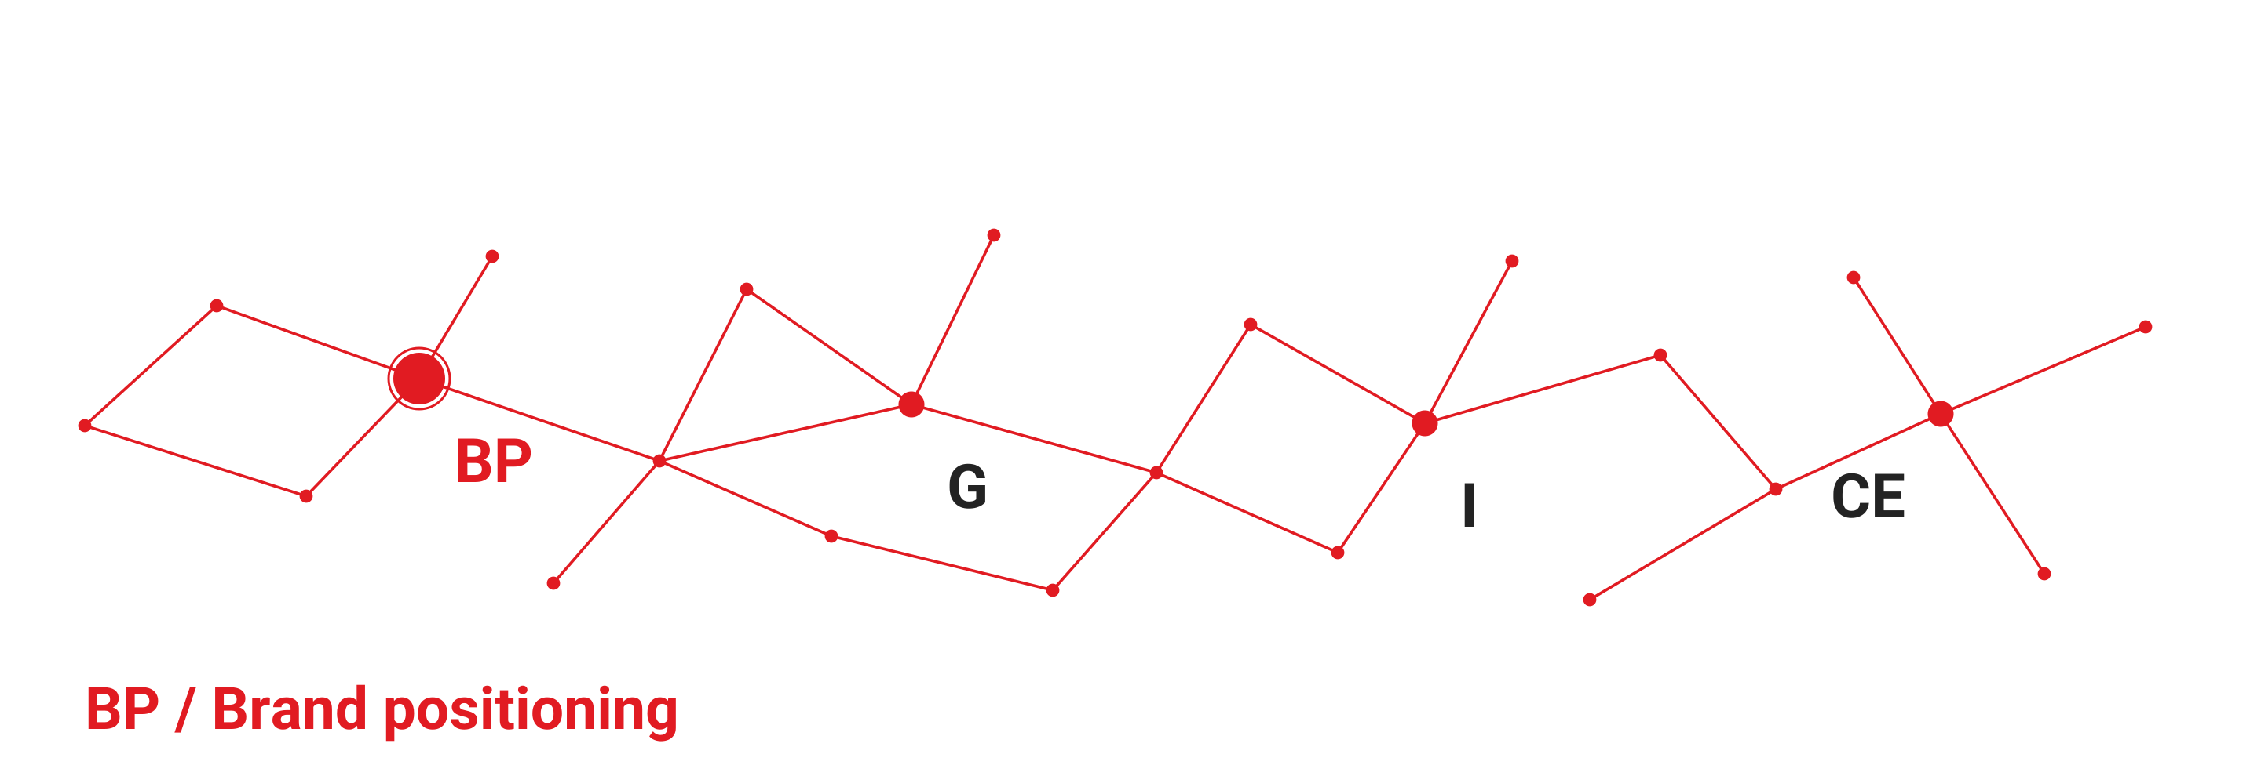
Define the position before planning how it appears across markets.
TRANSCENDING THE EQUILIBRIUM

01

The position to define
The first decision is the position the brand should own. This brief proposes a starting framework for agreeing that position before developing messages, local market adaptations and delivery materials.
The proposed sequence begins with the audience and the commercial problem. Evidence should then support a specific promise that the client can deliver consistently. The final wording, markets and scope remain subject to client review.

Objectives
- Agree a clear audience priority and the decision the brand needs to influence.
- Define a credible promise and the evidence needed to support it.
- Create a common basis for localised messaging and the first delivery plan.

Audience and context
Start with [priority audience] in [target market]. Record the audience’s role in the buying process, the outcome they seek and the concerns that may delay a decision. Separate observed needs from assumptions that still require validation.
Question | Evidence to gather
What is the audience trying to achieve? | Client interviews, sales conversations and relevant customer feedback.
What alternatives do they consider? | Competitor propositions and the reasons customers switch or stay.
What would make the promise credible? | Approved evidence, delivery capabilities and usable examples.

Decision required
Confirm one priority audience and one commercial problem for the first positioning round. Record secondary audiences separately so the initial proposition remains focused.
02

The proposition and market expression
A useful proposition makes the intended audience, benefit and reason to believe explicit. Treat the statement below as a working structure, then test the wording against client evidence and audience feedback.

Working proposition
For [priority audience] who need [relevant outcome], [Client brand] offers [specific value]. This is credible because [approved evidence or capability].

Message priorities
Layer | What the message should establish
Core promise | The specific value the audience should remember.
Supporting evidence | The proof that can be stated accurately and used with permission.
Next action | A relevant and proportionate next step for the audience.

Localisation approach
Keep the core promise and evidence consistent across markets. Adapt the language, examples and channel expression where local context changes how the audience understands or evaluates the offer.
- Confirm terminology with a reviewer who understands the target audience and market.
- Check that examples and imagery are locally relevant and do not imply unsupported claims.
- Review required disclosures and approval requirements with the appropriate client owner.

Review criteria
Assess each route for clarity, relevance, credibility and practical use. Prefer the route that the client can explain simply, substantiate and apply consistently. Capture disagreements with the evidence needed to resolve them.
03

Scope and decisions
The workplan below is a proposed sequence. Agree deliverables, responsibilities and timing with the client before work begins. Commercial terms and any additional services belong in the agreed scope.
Stage | Proposed output | Review point
Discover | Audience and evidence summary | Confirm the priority problem
Define | Positioning statement and message hierarchy | Select the preferred route
Adapt | Local market expression and content examples | Approve local interpretation
Prepare | Delivery brief and agreed asset list | Confirm readiness to proceed

Scope to confirm
Confirm [markets and languages], [deliverables], [review owners] and [delivery dates]. Identify existing assets that can be reused, dependencies on client input and any activities that need a separate proposal.

Decision log
Decision | Owner | Status
Priority audience and problem | [Name or role] | To confirm
Positioning route and supporting evidence | [Name or role] | To review
Markets and first delivery scope | [Name or role] | To agree

Next step
Use the next review to confirm the priority audience, evidence gaps and the person responsible for each open decision. Update this brief when those decisions are agreed.

